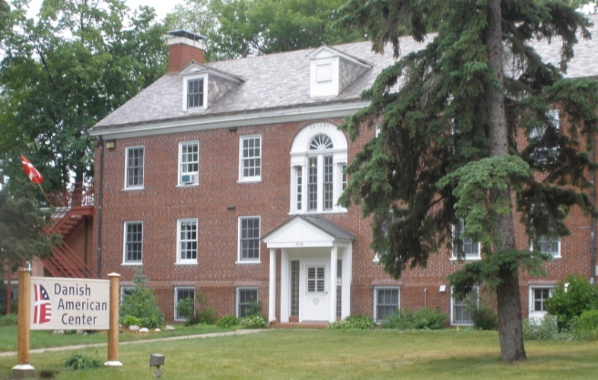

Thank you for donating to the Samfundssind Online Auction for the Danish American Center.
We need just a little bit of information in order to get your item listed properly.

Title Click or tap here to enter text.

Description (anything you think is important, we want to know, age, maker, etc.).
Click or tap here to enter text.
Fair Market Value Click or tap here to enter text.

Donated by: Click or tap here to enter text.

